Before :

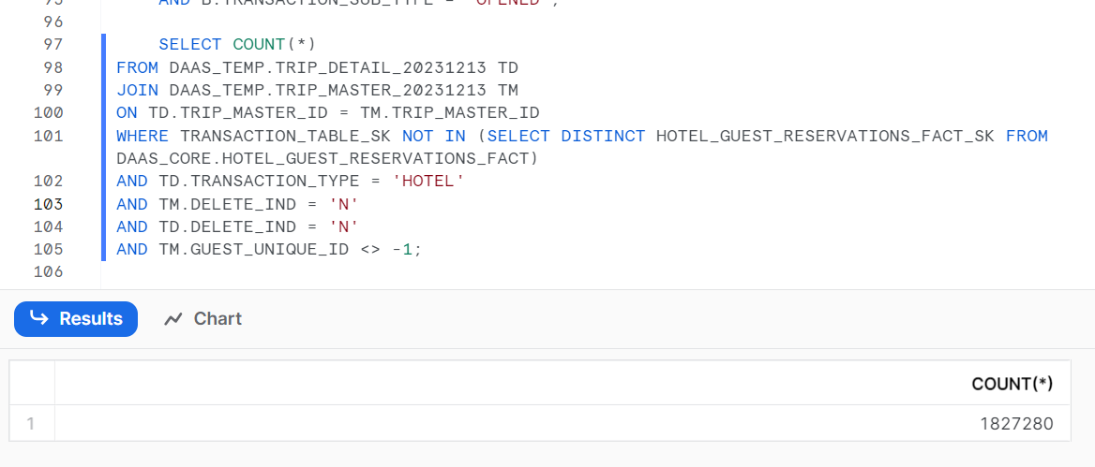

--Back up scripts

-- CALL DAAS_SECURITY.CLONE_TABLE_PROC('DAAS_PROD', 'DAAS_PROD', 'DAAS_CORE', 'DAILY_ACTIVITY_SUMMARY', NULL ,NULL);

-- CALL DAAS_SECURITY.CLONE_TABLE_PROC('DAAS_PROD', 'DAAS_PROD', 'DAAS_CORE', 'TRIP_SUMMARY', NULL ,NULL);

-- CALL DAAS_SECURITY.CLONE_TABLE_PROC('DAAS_PROD', 'DAAS_PROD', 'DAAS_CORE', 'TRIP_DETAIL', NULL ,NULL);

-- CALL DAAS_SECURITY.CLONE_TABLE_PROC('DAAS_PROD', 'DAAS_PROD', 'DAAS_CORE', 'TRIP_MASTER', NULL ,NULL);

-- CALL DAAS_SECURITY.CLONE_TABLE_PROC('DAAS_PROD', 'DAAS_PROD', 'DAAS_CORE', 'TRIP_MERGE_PROCESSED', NULL ,NULL);

-- CALL DAAS_SECURITY.CLONE_TABLE_PROC('DAAS_PROD', 'DAAS_PROD', 'DAAS_CORE', 'TRIP_MERGE_QUEUE', NULL ,NULL);

-- CALL DAAS_SECURITY.CLONE_TABLE_PROC('DAAS_PROD', 'DAAS_PROD', 'DAAS_CORE', 'TRIP_RECALC_PROCESSED', NULL ,NULL);

-- CALL DAAS_SECURITY.CLONE_TABLE_PROC('DAAS_PROD', 'DAAS_PROD', 'DAAS_CORE', 'TRIP_RECALC_QUEUE', NULL ,NULL);

Create_Temp_Hotel_SK.sql



select max(rank) from DAAS_TEMP.HOTEL_EXTRA_SKS_CLEANUP_TRIPS;//1727564

SELECT COUNT(*) FROM DAAS_TEMP.HOTEL_EXTRA_SKS_CLEANUP_TRIPS;//1827280

///

SELECT COUNT(A.TRIP_MASTER_ID) FROM DAAS_CORE.TRIP_MASTER A

JOIN DAAS_CORE.TRIP_DETAIL B ON A.TRIP_MASTER_ID = B.TRIP_MASTER_ID

JOIN (SELECT TM.TRIP_MASTER_ID FROM DAAS_CORE.TRIP_MASTER TM

WHERE TM.TRIP_MASTER_ID IN (SELECT DISTINCT TRIP_MASTER_ID FROM DAAS_TEMP.HOTEL_EXTRA_SKS_CLEANUP_TRIPS

WHERE RANK >= 500000)AND TM.DELETE_IND = 'N') C

ON A.TRIP_MASTER_ID = C.TRIP_MASTER_ID

WHERE A.DELETE_IND = 'N' AND B.TRANSACTION_SUB_TYPE = 'OPENED';//84888390

Update_Hotel_SK_Claenup.sql



--EXECUTE TASK DAAS_ADHOC. UPDATE_HOTEL_EXTRA_SKS_CLEANUP_TRIPS;

--EXECUTE TASK DAAS_ADHOC.INSERT_TRIP_RECALC_QUEUE;

////

EXECUTE TASK DAAS_COMMON.TRIP_RECALCULATION_ONDEMAND_TASK;

EXECUTE TASK DAAS_COMMON.TRIP_MERGE_CHECK_ONDEMAND_TASK;

EXECUTE TASK DAAS_COMMON.TRIP_MERGE_ONDEMAND_TASK;

EXECUTE TASK DAAS_COMMON.TRIP_CUSTOMER_MERGE_CHECK_GUEST_GUESTXREF_ONDEMAND_TASK;

EXECUTE TASK DAAS_COMMON.TRIP_CUSTOMER_MERGE_CHECK_TRIP_MASTER_ONDEMAND_TASK;

EXECUTE TASK DAAS_COMMON.TRIP_CUSTOMER_MERGE_ONDEMAND_TASK;

EXECUTE TASK DAAS_COMMON.TRIP_SUMMARY_WRAPPER_ONDEMAND_TASK;

///update the Update_Hotel_SK_Claenup.sql with rank >=500001

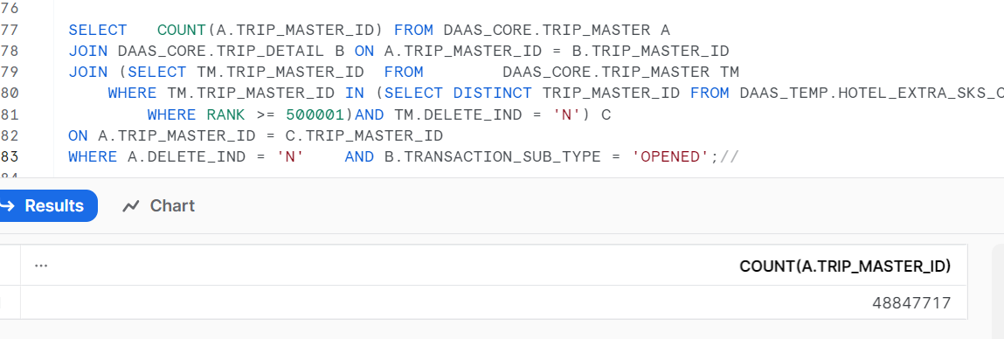

--EXECUTE TASK DAAS_ADHOC.UPDATE_HOTEL_EXTRA_SKS_CLEANUP_TRIPS;

--EXECUTE TASK DAAS_ADHOC.INSERT_TRIP_RECALC_QUEUE;

--EXECUTE TASK DAAS_COMMON.TRIP_RECALCULATION_ONDEMAND_TASK;

--EXECUTE TASK DAAS_COMMON.TRIP_MERGE_CHECK_ONDEMAND_TASK;

-- EXECUTE TASK DAAS_COMMON.TRIP_MERGE_ONDEMAND_TASK;

--EXECUTE TASK DAAS_COMMON.TRIP_CUSTOMER_MERGE_CHECK_GUEST_GUESTXREF_ONDEMAND_TASK;

--EXECUTE TASK DAAS_COMMON.TRIP_CUSTOMER_MERGE_CHECK_TRIP_MASTER_ONDEMAND_TASK;

-- EXECUTE TASK DAAS_COMMON.TRIP_CUSTOMER_MERGE_ONDEMAND_TASK;

--EXECUTE TASK DAAS_COMMON.TRIP_SUMMARY_WRAPPER_ONDEMAND_TASK;

